Guideline for Students: Peer Feedback for Smart Logistics
Prior to the Assessment, students engage in a dialogue about their individual contribution to the project. The students assign a score to each group member’s individual contribution to the group product, ranging between 80% and 120%. This score is the outcome of an evaluation and not a formal assessment. Each group member may distribute a total percentage equal to 100% times the number of group members. The evaluation must be shared with the project coach, who is also the assessor, no later than one working day before the assessment. Use the template associated with this project. The submitted distribution serves as a recommendation to the project coach. The assessor always reserves the right to deviate from this recommendation.
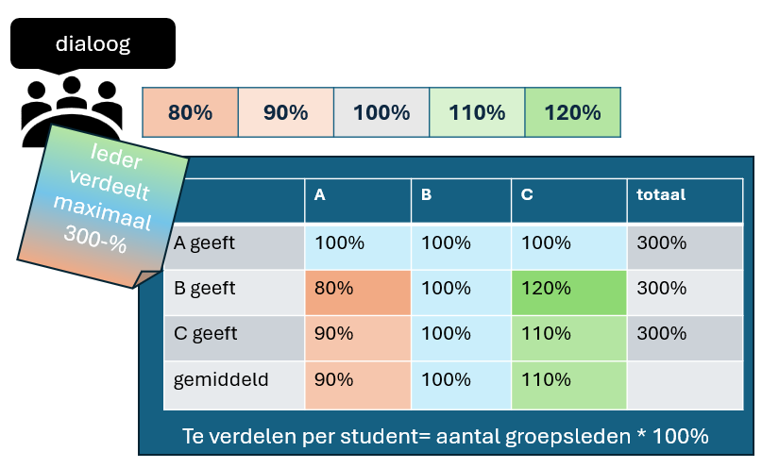
Evaluation Steps:
- Self-Evaluation
As preparation for the group dialogue, the student completes a self-evaluation using Form 1 (see excel in Brightspace). The student critically reflects on their own performance within the project team and assigns a score per criterion ranging from 80% to 120%. This score reflects how the student perceives their own performance in relation to that of their teammates. The student gathers information to justify their self-assigned scores to the group.
- Group Dialogue
Students bring their completed self-evaluation forms to the dialogue session and discuss the results with one another. Each student shares their own scores and receives feedback from peers. The conclusions from this dialogue are recorded in Form 2.
- Recommendation to Assessor
Based on Form 2 (see excel in Brightspace), students provide a collective recommendation to the assessor on how the project performance should be rated. This recommendation must be submitted to the project coach no later than one working day before the CGI.

